Федеральное государственное автономное образовательное учреждение высшего образования

Университет ИТМО

**Факультет программной инженерии**

**Образовательная программа СППО**

**Курсовая работа**

Вариант 120

Выполнил: **Нуруллаев Даниил Романович**Группа: **Р3114**

**Санкт-Петербург**

**2020г**

C=(A+B)mod8,5 входных переменных, 4 выходных переменных

A=(a1,a2);B=(b1,b2,b3);C=(C0,C1,C2);V-перенос

|  |  |  |  |  |  |  |  |  |
| --- | --- | --- | --- | --- | --- | --- | --- | --- |
| a1 | a2 | b1 | b2 | b3 | C0 | C1 | C2 | V |
| 0 | 0 | 0 | 0 | 0 | 0 | 0 | 0 | 0 |
| 0 | 0 | 0 | 0 | 1 | 0 | 0 | 1 | 0 |
| 0 | 0 | 0 | 1 | 0 | 0 | 1 | 0 | 0 |
| 0 | 0 | 0 | 1 | 1 | 0 | 1 | 1 | 0 |
| 0 | 0 | 1 | 0 | 0 | 1 | 0 | 0 | 0 |
| 0 | 0 | 1 | 0 | 1 | 1 | 0 | 1 | 0 |
| 0 | 0 | 1 | 1 | 0 | 1 | 1 | 0 | 0 |
| 0 | 0 | 1 | 1 | 1 | 1 | 1 | 1 | 0 |
| 0 | 1 | 0 | 0 | 0 | 0 | 0 | 1 | 0 |
| 0 | 1 | 0 | 0 | 1 | 0 | 1 | 0 | 0 |
| 0 | 1 | 0 | 1 | 0 | 0 | 1 | 1 | 0 |
| 0 | 1 | 0 | 1 | 1 | 1 | 0 | 0 | 0 |
| 0 | 1 | 1 | 0 | 0 | 1 | 0 | 1 | 0 |
| 0 | 1 | 1 | 0 | 1 | 1 | 1 | 0 | 0 |
| 0 | 1 | 1 | 1 | 0 | 1 | 1 | 1 | 0 |
| 0 | 1 | 1 | 1 | 1 | 0 | 0 | 0 | 1 |
| 1 | 0 | 0 | 0 | 0 | 0 | 1 | 0 | 0 |
| 1 | 0 | 0 | 0 | 1 | 0 | 1 | 1 | 0 |
| 1 | 0 | 0 | 1 | 0 | 1 | 0 | 0 | 0 |
| 1 | 0 | 0 | 1 | 1 | 1 | 0 | 1 | 0 |
| 1 | 0 | 1 | 0 | 0 | 1 | 1 | 0 | 0 |
| 1 | 0 | 1 | 0 | 1 | 1 | 1 | 1 | 0 |
| 1 | 0 | 1 | 1 | 0 | 0 | 0 | 0 | 1 |
| 1 | 0 | 1 | 1 | 1 | 0 | 0 | 1 | 1 |
| 1 | 1 | 0 | 0 | 0 | 0 | 1 | 1 | 0 |
| 1 | 1 | 0 | 0 | 1 | 1 | 0 | 0 | 0 |
| 1 | 1 | 0 | 1 | 0 | 1 | 0 | 1 | 0 |
| 1 | 1 | 0 | 1 | 1 | 1 | 1 | 0 | 0 |
| 1 | 1 | 1 | 0 | 0 | 1 | 1 | 1 | 0 |
| 1 | 1 | 1 | 0 | 1 | 0 | 0 | 0 | 1 |
| 1 | 1 | 1 | 1 | 0 | 0 | 0 | 1 | 1 |
| 1 | 1 | 1 | 1 | 1 | 0 | 1 | 0 | 1 |

**Минимизация булевых функций системы**

**1)С0**

|  |  |  |  |  |  |  |  |  |  |  |  |  |  |  |  |  |  |  |  |  |  |  |  |  |  |  |  |  |  |  |  |  |  |  |  |  |  |  |  |  |  |  |  |  |  |  |  |  |  |  |  |  |  |  |  |  |  |  |  |  |  |  |  |  |  |  |  |  |  |  |  |  |  |  |  |
| --- | --- | --- | --- | --- | --- | --- | --- | --- | --- | --- | --- | --- | --- | --- | --- | --- | --- | --- | --- | --- | --- | --- | --- | --- | --- | --- | --- | --- | --- | --- | --- | --- | --- | --- | --- | --- | --- | --- | --- | --- | --- | --- | --- | --- | --- | --- | --- | --- | --- | --- | --- | --- | --- | --- | --- | --- | --- | --- | --- | --- | --- | --- | --- | --- | --- | --- | --- | --- | --- | --- | --- | --- | --- | --- | --- |
| |  |  |  |  |  |  | | --- | --- | --- | --- | --- | --- | |  | b2b3 | | | | | | a2b1 |  | **00** | **01** | **11** | **10** | | **00** |  |  |  |  | | **01** | 1 | 1 | 1 | 1 | | **11** | 1 | 1 |  | 1 | | **10** |  |  | 1 |  | | a1 = 0 | | | | | | |  |  |  |  |  |  | | --- | --- | --- | --- | --- | --- | |  | b2b3 | | | | | | a2b1 |  | **00** | **01** | **11** | **10** | | **00** |  |  | 1 | 1 | | **01** | 1 | 1 |  |  | | **11** | 1 |  |  |  | | **10** |  | 1 | 1 | 1 | | a1 = 1 | | | | | |

Sa=27 ;Sb= 35 ;

C0= a1b2 v a1a2b3 v a2b2b3 v b1 v b1 v b1 v b1 v b1

**2)C1**

|  |  |  |  |  |  |  |  |  |  |  |  |  |  |  |  |  |  |  |  |  |  |  |  |  |  |  |  |  |  |  |  |  |  |  |  |  |  |  |  |  |  |  |  |  |  |  |  |  |  |  |  |  |  |  |  |  |  |  |  |  |  |  |  |  |  |  |  |  |  |  |  |  |  |  |  |
| --- | --- | --- | --- | --- | --- | --- | --- | --- | --- | --- | --- | --- | --- | --- | --- | --- | --- | --- | --- | --- | --- | --- | --- | --- | --- | --- | --- | --- | --- | --- | --- | --- | --- | --- | --- | --- | --- | --- | --- | --- | --- | --- | --- | --- | --- | --- | --- | --- | --- | --- | --- | --- | --- | --- | --- | --- | --- | --- | --- | --- | --- | --- | --- | --- | --- | --- | --- | --- | --- | --- | --- | --- | --- | --- | --- |
| |  |  |  |  |  |  | | --- | --- | --- | --- | --- | --- | |  | b2b3 | | | | | | a2b1 |  | **00** | **01** | **11** | **10** | | **00** |  |  | 1 | 1 | | **01** |  |  | 1 | 1 | | **11** |  | 1 |  | 1 | | **10** |  | 1 |  | 1 | | a1 = 0 | | | | | | |  |  |  |  |  |  | | --- | --- | --- | --- | --- | --- | |  | b2b3 | | | | | | a2b1 |  | **00** | **01** | **11** | **10** | | **00** | 1 | 1 |  |  | | **01** | 1 | 1 |  |  | | **11** | 1 |  | 1 |  | | **10** | 1 |  | 1 |  | | a1 = 1 | | | | | |

Sa=20 ;Sb= 26 ;

C1= a1 v a1 v a1a2b2b3 v a2b3 v b2 v b2

**3)C2**

|  |  |  |  |  |  |  |  |  |  |  |  |  |  |  |  |  |  |  |  |  |  |  |  |  |  |  |  |  |  |  |  |  |  |  |  |  |  |  |  |  |  |  |  |  |  |  |  |  |  |  |  |  |  |  |  |  |  |  |  |  |  |  |  |  |  |  |  |  |  |  |  |  |  |  |  |
| --- | --- | --- | --- | --- | --- | --- | --- | --- | --- | --- | --- | --- | --- | --- | --- | --- | --- | --- | --- | --- | --- | --- | --- | --- | --- | --- | --- | --- | --- | --- | --- | --- | --- | --- | --- | --- | --- | --- | --- | --- | --- | --- | --- | --- | --- | --- | --- | --- | --- | --- | --- | --- | --- | --- | --- | --- | --- | --- | --- | --- | --- | --- | --- | --- | --- | --- | --- | --- | --- | --- | --- | --- | --- | --- | --- |
| |  |  |  |  |  |  | | --- | --- | --- | --- | --- | --- | |  | b2b3 | | | | | | a2b1 |  | **00** | **01** | **11** | **10** | | **00** |  | 1 | 1 |  | | **01** |  | 1 | 1 |  | | **11** | 1 |  |  | 1 | | **10** | 1 |  |  | 1 | | a1 = 0 | | | | | | |  |  |  |  |  |  | | --- | --- | --- | --- | --- | --- | |  | b2b3 | | | | | | a2b1 |  | **00** | **01** | **11** | **10** | | **00** |  | 1 | 1 |  | | **01** |  | 1 | 1 |  | | **11** | 1 |  |  | 1 | | **10** | 1 |  |  | 1 | | a1 = 1 | | | | | |

Sa=4 ;Sb= 6 ;

C2= a2 v b3

**3)V**

|  |  |  |  |  |  |  |  |  |  |  |  |  |  |  |  |  |  |  |  |  |  |  |  |  |  |  |  |  |  |  |  |  |  |  |  |  |  |  |  |  |  |  |  |  |  |  |  |  |  |  |  |  |  |  |  |  |  |  |  |  |  |  |  |  |  |  |  |  |  |  |  |  |  |  |  |
| --- | --- | --- | --- | --- | --- | --- | --- | --- | --- | --- | --- | --- | --- | --- | --- | --- | --- | --- | --- | --- | --- | --- | --- | --- | --- | --- | --- | --- | --- | --- | --- | --- | --- | --- | --- | --- | --- | --- | --- | --- | --- | --- | --- | --- | --- | --- | --- | --- | --- | --- | --- | --- | --- | --- | --- | --- | --- | --- | --- | --- | --- | --- | --- | --- | --- | --- | --- | --- | --- | --- | --- | --- | --- | --- | --- |
| |  |  |  |  |  |  | | --- | --- | --- | --- | --- | --- | |  | b2b3 | | | | | | a2b1 |  | **00** | **01** | **11** | **10** | | **00** |  |  |  |  | | **01** |  |  |  |  | | **11** |  |  | 1 |  | | **10** |  |  |  |  | | a1 = 0 | | | | | | |  |  |  |  |  |  | | --- | --- | --- | --- | --- | --- | |  | b2b3 | | | | | | a2b1 |  | **00** | **01** | **11** | **10** | | **00** |  |  |  |  | | **01** |  |  | 1 | 1 | | **11** |  | 1 | 1 | 1 | | **10** |  |  |  |  | | a1 = 1 | | | | | |

Sa=11 ;Sb= 14 ;

V= a1b1b2 v a2b1b2b3 v a1a2b1b3

C0= a1b2 v a1a2b3 v a2b2b3 v b1 v b1 v b1 v b1 v b1

C1= a1 v a1 v a1a2b2b3 v a2b3 v b2 v b2

C2= a2 v b3

V= a1b1b2 v a2b1b2b3 v a1a2b1b3

При реализации схемы в виде шести независимых подсхем ее цена SQ = 80

**Преобразование минимальных форм булевых функций системы**

C0= a2b3(a1 v b2) v b1( v ) v b1( ) v a1b2 v b1

C1= a1( v ) v a2b3(a1b2 v ) v b2(v )

C2= a2 v b3

V=b1b2(a1 v a2b3) v a1a2b1b3

За счет раздельной факторизации цена схемы уменьшилась: SQ = 68

Z1= v ()

Z2=a2b3 ()

Z3=a1 v b2()

Z4=a1b2()

Z5=Z4v()

C0= a2b3Z3 v b1v b1v a1b2 v b1

C1= a1Z1 v a2b3Z5 v b2Z1

C2= z1(a2 v b3)

V=b1b2(a1 v z2) v a1a2b1b3

После совместной факторизации цена схемы SQ = 48

**Синтез многовыходной комбинационной схемы в булевом базисе**

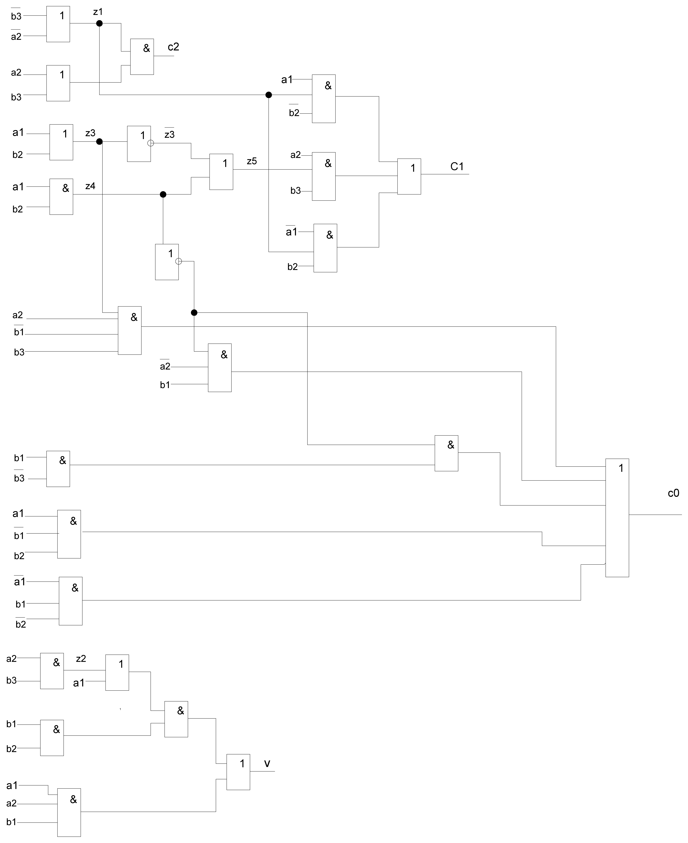

TC0=4τ, TC1=5τ, TC2=2 ,Tv=4τ

T= max (TC0, TC1, TC2, Tv)= 5τ.